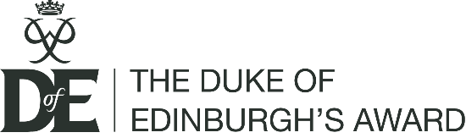
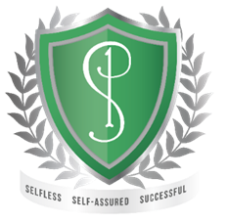
January 2022
Dear Parent/Guardian,

I am writing to introduce you to the Duke of Edinburgh’s Award and to explain the enrolment process for Bronze Award participants at Priory School.

The Duke of Edinburgh’s Award is the world’s leading youth achievement award and is a globally recognised Award. There are three levels: Bronze, Silver and Gold, which differ in terms of increasing time commitment, degree of challenge and age of entry. The benefits of achieving an Award at any level are endless. It encourages young people to push themselves to do new things, grow in confidence and develop new skills. The Award is highly valued and respected by both employers and further or higher education establishments.

We are providing the opportunity to undertake the Bronze Award to all students in Year 10. In completing the Award over the next few months, students will undertake four sections as part of their own personal and unique journey. These are Physical, Skills, Volunteering & Expedition.

Every young person’s DofE programme is personal to them – they can choose what they’d like to do for their Physical, Skills and Volunteering sections, and most activities can count. We will provide guidance and support, and students can either choose to continue an activity they already do or discover something completely new.
During and in the aftermath of the COVID-19 pandemic, participants who complete their Physical, Skills and Volunteering sections will also receive a DofE Certificate of Achievement – a formal recognition, by the DofE, of their efforts at this extraordinary time.
With the current restrictions around social distancing and running school trips, to begin with the focus will be on completing the Physical, Skills and Volunteering sections. As the schools DofE Manager I will be liaising with DofE and SLT to find suitable dates to run the Training and Qualifying Expedition, however no payment will be taken for this section until a solution is found and the focus to begin with will be on the other 3 sections.

Timescales:
Students can get started on their non-expedition sections as soon as they are registered. The school’s DofE Manager and team of DofE Leaders will be on hand to support the students throughout the award to offer advice & ensure they record their activities correctly on eDofE (the online account). Two of the sections must be completed over a three-month period and the third over a sixth month period, for one hour per week. For a list of ideas for each section please visit: www.dofe.org/do/ideas/

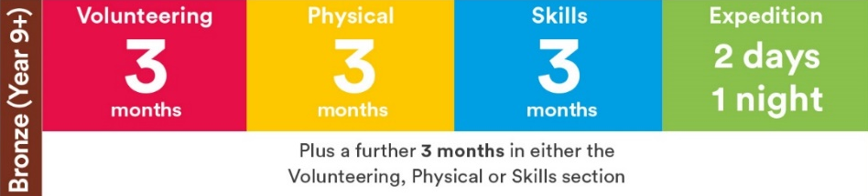
About the expedition
At Priory School, the expedition section is completed under the supervision and guidance of Mrs Clare Wassall, who will ensure that the expedition meets the requirements of the award. The DofE has introduced a number of flexibilities to allow expeditions to take place safely, in line with social distancing restrictions, however the school will still need to follow Government guidance.
This section will involve training and a qualifying expedition, and students are in teams of 4 – 7. Times, dates, and locations should be confirmed later in the academic year. If it is not possible to run the Expedition section this academic year due to Covid restrictions, then students can still achieve their DofE Certificate of Achievement.

The DofE and COVID-19
Your child can still have the full DofE experience, safely and in line with Government guidance, during the COVID-19 outbreak. The motivation and focus the DofE gives, and its positive impact on mental and physical health, can play an important role in helping your child navigate our ‘new normal’, safely expanding their world and giving them skills and experiences to open doors in the future. As participants can choose and change their activities, they can pick ones that they can do while social distancing or from home. The DofE has provided useful advice and information, including activity and volunteering ideas, at dofe.org/dofewithadifference.
eDofE and the DofE app
Participants can create their DofE programme and record their progress using eDofE, the DofE’s digital system, available online at eDofE.org and through the DofE app – downloadable for free from Google Play and the App Store.
When your child enrols, we will set up their eDofE account and they will receive details of how to sign in and get started.
Signing up
The cost of taking part in the DofE is £60 per participant. This will get your child enrolled on to the award and covers a contribution to the school’s licence fee.
If it is possible to deliver the Expedition section, there will be a further payment later in the academic year. For now, the focus is on the Certificate of Achievement.
If your child would like to take part, please complete and return the enclosed enrolment form, together with the sum of £60 to Priory School or via parent pay by 28th February 2022.
Many thanks for your support and we look forward to helping your child to achieve through their DofE.
Yours faithfully,
Mrs Clare Wassall
DofE Manager

DofE Enrolment Form 1 of 2

Please print clearly in CAPITALS or type your details in. You must complete all of the questions.

DofE Centre and group details (if you know them):
DofE Centre: The Priory School | DofE group: Bronze 2020/2021

DofE level:
Bronze

Personal details:
First name: | Last name:
Date of birth: / / | Primary language English Welsh Other
Email address (this is the email address that will be registered on eDofE – your online account):

When you first sign in to eDofE you will be asked to record some personal details such as your contact details, ethnicity and personal circumstances along with details of any medical needs you may have. This data is used to enable your Leaders to support you doing your DofE programme and for the DofE’s statistical and reporting purposes. You will always have a ‘prefer not to say’ option.

Declaration:
I agree to enrol as a participant on a DofE programme. I understand that I will be managing my programme using the online eDofE system. I acknowledge that this system has a set of terms and conditions that I agree to. These terms and conditions are available at www.eDofE.org

Print Name | Signature | Date
 |  | / /

DofE Enrolment Form 2 of 2

Consent to enrol from parent or guardian (if applicant is under 18 years old).
I agree to my son / daughter / ward doing a DofE programme. I note that it is my responsibility to check that any activity my son / daughter / ward undertakes for their DofE programme is appropriately managed and insured, unless the activity is directly managed or organised by their DofE group, centre or Licensed Organisation.
Print Name | Signature | Date
 |  | / /

Note:
Data supplied on this form and in eDofE and information about DofE activities recorded in eDofE will be used by the DofE Charity, the Licensed Organisation and DofE centre to monitor and manage DofE participation and progress by young people and manage and support Leaders.

The DofE Charity will use personal data to communicate useful and relevant information to either help participants complete a DofE programme, Leaders/LOs to run DofE programmes more effectively or help the DofE Charity to improve the quality and breadth of its programmes.

We also send emails that contain information about the Charity, DofE negotiated privileged discounts and invites to events and other activities however if you would like to receive these emails you will need to opt in. Once you have opted-in to this you can opt out at any time by visiting www.dofe.org/preferences, or clicking the unsubscribe link that can be found at the bottom of all non-programme related email.

Please fill this out and keep it for your own records. You will need this information when you log on to eDofE for the first time.

