How to sign up

- Go to http://www.squadintouch.co.uk/

- Click on the sign up / sign in button and then click Sign in or join us for free
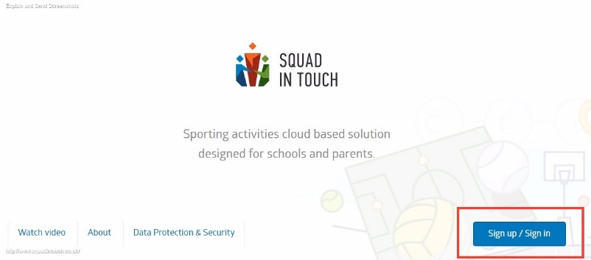

- Then input all the correct information

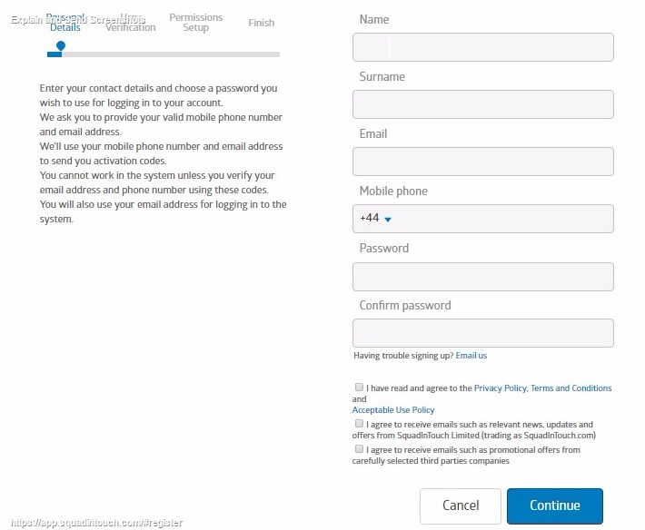

- Once you have entered all of the correct information, you will receive a text and email notification to verify your identity

- If you don’t receive one, let a member of the Squad In Touch support team know. support@squadintouch.co.uk
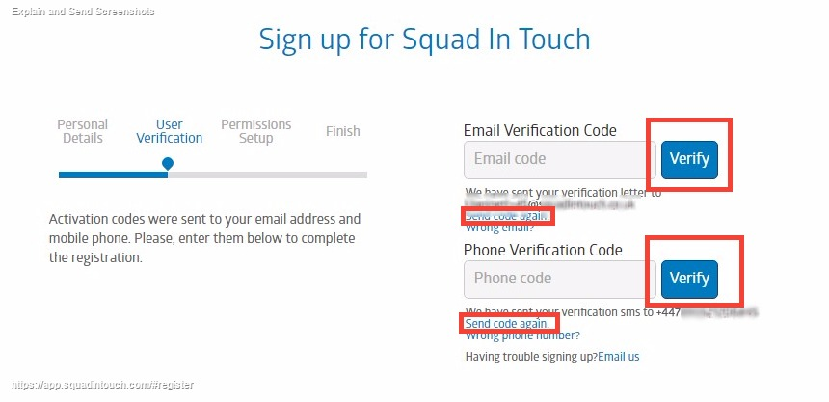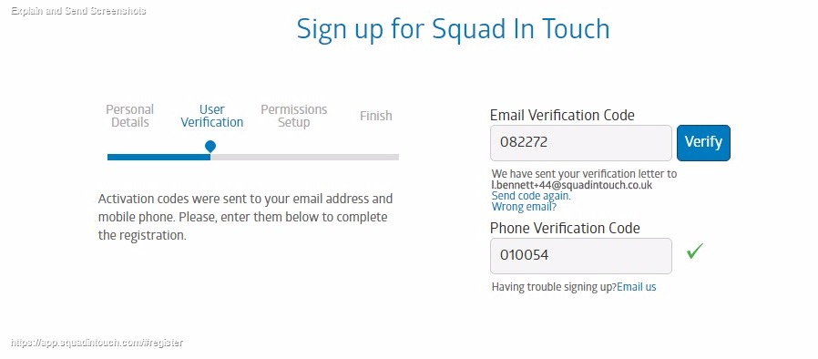
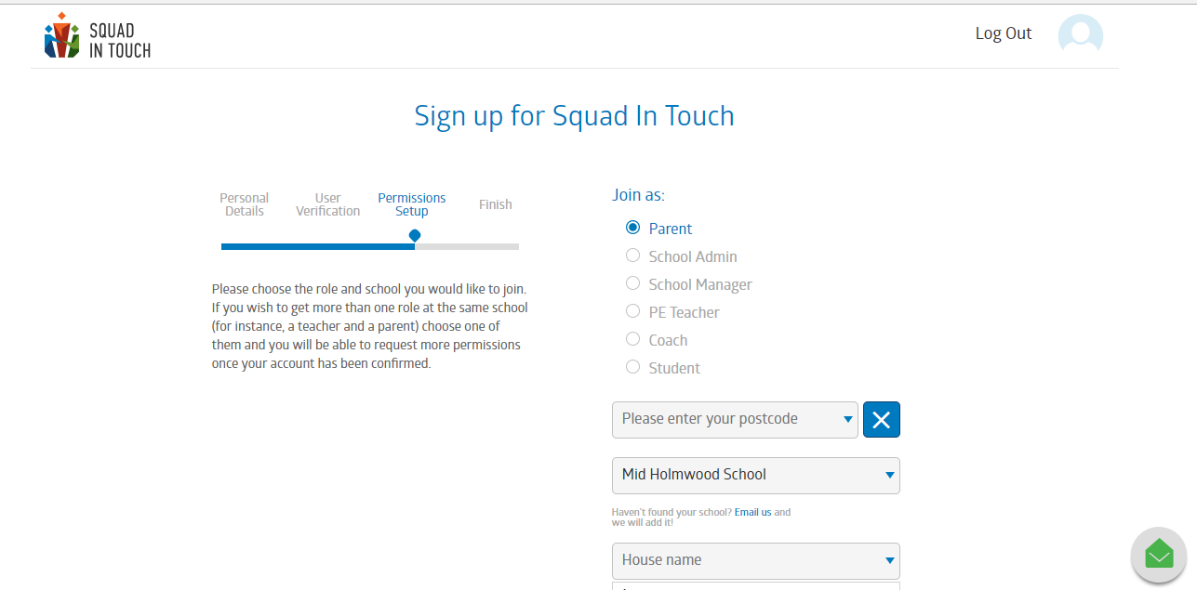
- Choose your school role and select the school you are a part of - if you have multiple roles then his can be sorted later, after your initial sign up is completed.

- Then enter the details of your child, their house name, form group and their first and last name

- If you have more than one child at the same or another school, just click ‘Add child’

- Then click ‘Continue’ and wait to be accepted. This could take a couple of days as it is up to the school to check your credentials and then accept you.

