Applicant Information Pack
Teaching Assistant – Level 2
Maternity cover

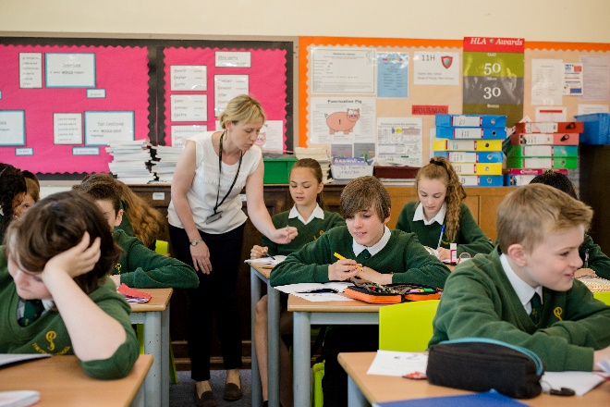
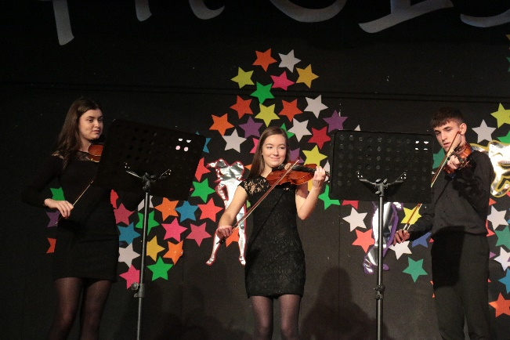

Headteacher Letter to Applicants

The Priory School is an oversubscribed, 11-16, comprehensive situated in a popular, residential area of the County Town of Shrewsbury. There are approximately 840 students on roll with a six-form entry. The school has an excellent reputation across the county.
Our main school building dates from the late 1930s, with a mix of additional classroom blocks added over time, to cater for the growing needs of the school. Our latest ‘Maths Block’ opened in 2019 and symbolises our determination to provide our students with a first-class environment, conducive to learning.
As soon as you enter our school you gain a ‘feel’ for our very special ethos and culture. Students conduct themselves in an exemplary manner and have high expectations of their own and others’ conduct, both in and out of lessons. They are a pleasure to teach and be with. We are an inclusive school and value the diversity of our student body. Outcomes for our students are above average and progress over the last three years has improved year on year. We are determined to ensure this remains the case and constantly reflect on all that we do to ensure we continually improve.
We have a vibrant House System that embodies all we stand for and our students participate in a range of activities, in large numbers. The system helps us to celebrate a range of talents and interests, complementing an extensive extra-curricular programme and has become an integral part of ‘Priory Life’. We believe education is about developing the individual holistically, not just academically. As a result, we have a rich and broad curriculum, to ensure the development of all our students into Selfless, Self-Assured, and Successful individuals.
Our staff are a close-knit team who are dedicated to ensuring our students have the best experience of school life. School leadership are committed to their continued professional development and have placed significant emphasis on staff well-being; reviewing workload to support a healthy work-life balance.
The successful applicant will be joining us at an exciting time of our development, both as a school and as part of an evolving multi-academy trust. They will work within a school, which prides itself on being outward facing, dynamic and aspirational whilst retaining an important feel of the traditional.
If you choose to join the Priory School you will not only benefit from joining an exceptional school, you will greatly benefit from working within an aspirational family of schools. Please take time to view our website https://priory.tpstrust.co.uk/ for more details.

Alison Pope
Headteacher

About our Trust

Our Multi-Academy Trust (MAT) was established in 2016 with two schools, The Priory School and St Martins, a 3-16 school in North Shropshire. In July 2017, we were joined by Coleham School, a 4-11 school in Shrewsbury and a fourth school, Thomas Adams, joined us in March 2020. Thomas Adams is located in Wem and is an 11-18 comprehensive state boarding school, with approximately 1200 students. In April 2021 we were joined by William Brookes School an 11-18 school in Much Wenlock. We have hopes of further growth in the near future. The MAT provides a most interesting and exciting opportunity for schools to share ideas, resources and expertise, for the added benefit of the students in the Trust.

“The value of the individual, the benefit of the team”
This statement heads our Strategy document and establishes the values by which we want our schools to work collaboratively. We are an evolving Trust in terms of our size and operation, in that as new schools seek to join us we look in turn to adapt the way we work together. In short, the leaders within the MAT are keen to receive expertise and share best practice. We want schools to retain their identity, character and ethos, all within the shared values of developing students who are selfless, self-assured and successful. The aspiration of the Trust is that every school gives and receives support and every child is in a great school.
Please take a look at our Trust website https://www.3-18education.co.uk/ for more details.

Learning Support at The Priory School
Our Learning Support department is made up of 4 HLTAs and 14 Teaching Assistants. They support a variety of students with special educational needs in the classroom, interventions, small groups and sometimes on a 1:1 basis. The department is integral to our success as a school; this has increased with the impact of the COVID pandemic on our young people. We now have a Support HUB in school where the team are based which has greatly enhanced the way in which they work. They are line managed by our SENDCo and work closely with our Heads of House and Student Support to create a joined up approach to achieving student success.

Job Description
Title of Post: | Teaching Assistant Level 2
Post Status | Fixed Term
Grade and SCP | Grade 5 SCP 5-6
Accountable to: | SENDCo

Main purpose
- Work with class teachers to raise the learning and attainment of pupils
- Promote pupils’ independence, self-esteem and social inclusion
- Give support to pupils, individually or in groups, so they can access the curriculum, take part in learning and experience a sense of achievement

Duties and responsibilities

Support for Students
- Demonstrate an informed and efficient approach to teaching and learning by adopting relevant strategies to support the work of the teacher and increase achievement of all pupils including, where appropriate, those with special educational needs and disabilities (SEND)
- Provide in-class support through promoting, supporting and facilitating inclusion by encouraging participation of all pupils in learning and extracurricular activities
- Assist with the supervision of pupils out of directed lesson time, including lunchtimes as required, within working hours
- Use effective behaviour management strategies consistently in line with the school’s policy and procedures
- Support class teachers with maintaining good order and discipline among pupils, managing behaviour effectively to ensure a good and safe learning environment
- Help maintain a stimulating and safe learning environment
- Observe pupil performance and pass observations on to the class teacher
- Use ICT skills to advance pupils’ learning
- Undertake exam invigilation, following training provided
- Undertake any other relevant duties given by the class teacher

Support for SENDCo/Teachers
- Contribute to effective assessment and planning, under the direction of a teacher/SENDCo, by supporting the monitoring, recording and reporting of pupil performance and progress as appropriate to the level of the role
- Collaboratively plan how to support the inclusion of pupils in the learning activities
Working with colleagues and other relevant professionals
- Communicate effectively with other staff members and pupils, and with parents and carers in your role generally and also as a Keyworker.
- Communicate knowledge and understanding of pupils to other school staff and education, health and social care professionals, so that informed decision making can take place on intervention and provision
- With the SENDCO, keep other professionals accurately informed of performance and progress or concerns about students working with
- Understand the role in order to be able to work collaboratively with teachers and other colleagues, including specialist advisory teachers
- Collaborate and work with colleagues and other relevant professionals within and beyond the school
- Develop effective professional relationships with colleagues

Professional development
- Help keep knowledge and understanding relevant and up-to-date by reflecting on your own practice, liaising with school leaders, and identifying relevant professional development to improve personal effectiveness
- Take opportunities to build the appropriate skills, qualifications, and/or experience needed for the role, with support from the school

Other Responsibilities
- Comply with and assist with the development of policies and procedures relating to child protection, health, safety and security, confidentiality and data protection, reporting all concerns to an appropriate person.
- Be aware of and comply with all school policies and procedures
- Be aware of and support difference and ensure equal opportunities for all
- Contribute to the overall ethos and aims of the School and Trust
- Appreciate and support the role of other professionals
- Attend and participate in relevant meetings, training and learning activities as required

The postholder may be required to carry out any other duties that the Headteacher feels are commensurate with the post. Whilst every effort is made to explain the main duties and responsibilities of the post each individual task undertaken may not be identified.

This job description is subject to review by the Headteacher, in negotiation with the post holder at any time. However, an annual review of this job description and allocation of responsibilities will take place as part of agreed performance management arrangements.

Person Specification
 | Essential | Desirable
Qualifications | - GCSEs at grades 9 to 4 (A* to C) including English and maths | - First Aid qualification  - Teaching Assistant Induction Training  - Teaching Assistant NVQ Level 2 or have completed training of a similar standard
Work or relevant experience | - At least 2 years relevant work experience working in a relevant setting  - Ability to plan and organise effectively | - Some experience of classroom administration support
Knowledge and Understanding | - A good knowledge of school based education including child development | - Understanding of roles and responsibilities within the classroom and whole school context  - Knowledge of how to help adapt and deliver support to meet individual needs  - Knowledge of guidance and requirements around safeguarding children  - Knowledge of national learning strategies including literacy and numeracy
Skills and Abilities (relevant to post) | - Sufficiently fluent in spoken English to ensure effective performance in the role  - Good literacy and numeracy skills  - Good organisational skills  - Active listening skills  - Excellent verbal communication skills  - Ability to build effective working relationships and relate well to children, staff and parents  - Evidence of working well as part of a team | - Skills and expertise in understanding the needs of all pupils  - The ability to remain calm in stressful situations  - Good ICT skills, particularly using ICT to support learning  - Specialist skills, training or experience e.g. Art, Music, ICT etc.
Personal qualities | - Enjoyment of working with children  - Sensitivity and understanding, to help build good relationships with pupils  - A commitment to getting the best outcomes for all pupils and promoting the ethos and values of the school  - Commitment to maintaining confidentiality at all times  - Commitment to safeguarding pupil’s wellbeing and equality  - Ability to bring to the role, initiative, enthusiasm and commitment  - Flexibility and reliability  - Willingness to develop skills with further training
Special Conditions | - Willingness to undertake an enhanced Disclosure and Barring Service (DBS) check.

Further Information
We are the lead school for Shropshire and Telford Education Partnership the DfE sponsored Teaching School Hub which covers Shropshire and Telford and Wrekin. We work in collaboration with three other former teaching school alliances to deliver the Early Career Framework, act as an Appropriate Body for Early Career Teachers, deliver the full suite of NPQs, offer School Direct PGCEs through our wider partnership as well as provide accredited CPD to meet the needs of the area. This signals a very exciting new chapter for the school in its contribution to the wider development of teaching and support staff across the local area.

We are also the lead school for the Shropshire, Herefordshire and Wolverhampton (SHaW) Maths Hub. Our Maths Hub work, which arises through our Teaching School status, covers Shropshire, Herefordshire and Wolverhampton, and has seen significant growth and success since its inception in 2014.

The Appointment Process
Applications will only be accepted from applicants completing the Application Form in full. We do not accept CV’s in support of an application.

The Application Form can be found on our website and all applications will be acknowledged.

Interviews will be offered to those applicants who best demonstrate how skills, abilities and experience match the person specification, taking into consideration the job description.

Closing date for applications: 10am Monday 4th July 2022

Interviews: Thursday 7th July 2022

If you have any questions based on any aspect of the appointment process, need additional information, or would like to visit the school, please contact Jo Kewell, at: jmk@tpstrust.co.uk

Please return completed applications to: Jo Kewell, at: hr@tpstrust.co.uk/ or applications can be returned to The Priory School Trust, Longden Road, Shrewsbury, SY3 9EE

The 3-18 Education Trust is committed to safeguarding and promoting the welfare of children and young people, as such this post requires acknowledgement and understanding of safeguarding and child protection policies. Policies can be found on the school website : Click Here

This post is exempt from the Rehabilitation of Offenders act 1974 and as such the applicant who is appointed to this post will be subject to an Enhanced Disclosure before the appointment is confirmed. This check will include details of cautions, reprimands or warnings, as well as convictions and non-conviction information. Once appointed, the successful applicant may also be required to apply for an Enhanced Disclosure at intervals during the course of their employment whilst in this post.

